## U.S. Department of State

OMB Control No.: 1405-0160 Expiration Date: 04-30-2025 Estimated Burden: 40 Minutes

# APPLICATION FOR A U.S. PASSPORT FOR ELIGIBLE INDIVIDUALS

##### CORRECTION, NAME CHANGE TO PASSPORT ISSUED 1 YEAR AGO OR LESS, AND LIMITED PASSPORT REPLACEMENT

**Please read all instructions first and type or print in black ink to complete this form.**

For information or questions, visit travel.state.gov or contact the National Passport Information Center (NPIC) at 1-877-487-2778 (TDD/TTY: 1-888-874-7793) or [NPIC@state.gov**.**](mailto:NPIC@state.gov)

|  |
| --- |
| **SECTION A. ELIGIBILITY TO USE THIS FORM** |
| This form is used by U.S. passport holders who are eligible to re-apply for a U.S. passport book and/or card (a travel document attesting to one’s identity and issued to U.S. citizens or non-citizen U.S. nationals) at no cost (unless expedited service is requested for a name change or limited passport replacement). This form can be submitted by mail. You are eligible to use this form if you can answer “Yes” to any of the statements below about your passport:  I changed my name, by marriage or court order, less than one year after my most recent U.S.  **YES NO** passport book and/or card was issued and my U.S. passport book and/or card was issued less than one year ago.  **-- OR --**  **YES NO** My identifying information in my most recent U.S. passport book and/or card was printed incorrectly.  **-- OR --**  **YES NO** My most recent U.S. passport book was obtained at the full passport fee and limited to two years or less for a reason other than multiple losses or serious damage/mutilation of previous passports. |
| **If you answered "NO" to ALL the statements above, STOP. You cannot use this form.**  **You may be eligible to apply on form DS-11 or DS-82 depending on your circumstances.**  **Visit travel.state.gov for more information.** |
| **Notice to Applicants for No-Fee Regular, Service, Official, or Diplomatic Passports:** You may use this application if you meet all provisions listed; however, you must consult your sponsoring agency for instructions on proper routing procedures before forwarding this application. Your completed passport will be released to your sponsoring agency and forwarded to you.  **Replacing a Lost, Stolen, or Damaged Passport:** A United States citizen or non-citizen national may not normally have more than one valid or potentially valid U.S. passport book or more than one valid or potentially valid U.S. passport card at a time.  Therefore, when a valid or potentially valid U.S. passport book or card cannot be presented with a new application, you must apply using form DS-11, Application for a U.S. Passport and submit form DS-64, Statement Regarding a Lost or Stolen Valid U.S. Passport.  The information you provide regarding your lost or stolen valid U.S. passport book or card will be placed into our Consular Lost or Stolen Passport System. This system is designed to prevent the misuse of your lost or stolen U.S. passport book or card. Anyone using the passport book or card that was reported lost or stolen may be detained upon entry into the United States. I**f you find the**  **U.S. passport book or card that was reported lost or stolen, immediately report it as found and submit it for cancellation. It has been invalidated. You cannot use that passport book or card for travel.** |
| **SECTION B. STEPS TO REAPPLY FOR A U.S. PASSPORT** |
| 1. Complete and sign this form. 2. Attach one color photograph 2x2 inches in size and your issued U.S. passport and supporting documents (See Section D of these instructions). 3. Mail us your application and attachments (See Section E of these instructions). 4. Track application status online at Passportstatus.state.gov. 5. Receive new passport and original supporting documents (that you submitted with your application). |



|  |  |  |
| --- | --- | --- |
| **SECTION C. HOW TO COMPLETE THIS FORM**  Please see the instructions below for items on the form that are not self-explanatory. The numbers match the numbered items of the form. | | |
| **1. Name (Last, First, Middle)**: Enter the name to appear in the passport. If you are requesting a passport in a name different from the name that appears on your previous U.S. passport, submit proof of name change if resulting from marriage or legal name change such as a marriage certificate, divorce decree, or court order of name change (if applicable). Information can be found at travel.state.gov/namechange. | | |
| **2. Date of Birth**: Use the following format: Month, Date, and Year (MM/DD/YYYY). | | |
| **3. Gender**: The gender markers used are “M” (male), “F” (female) and “X” (unspecified or another gender identity). The gender marker that you check on this form will appear in your passport regardless of the gender marker(s) on your previous passport and/or your supporting evidence of citizenship and identity. If changing your gender marker from what was printed on your previous passport, select “Yes” in this field on Application Page 1. If no gender marker is selected, we may print the gender as listed on your supporting evidence or contact you for more information. **Please Note**: We cannot guarantee that other countries you visit or travel through will recognize the gender marker on your passport. Visit travel.state.gov/gender for more information. | | |
| **4. Place of Birth**: Enter the name of the city and state if in the U.S. or city and country as presently known. | | |
| **5. Social Security Number**: You must provide a Social Security number (SSN), if you have been issued one, in accordance with Section 6039E of the Internal Revenue Code (26 U.S.C. 6039E) and 22 U.S.C 2714a(f). If you do not have a Social Security number, you must enter zeros in this field and submit a statement, signed and dated, that includes the phrase, “*I declare under penalty of perjury under the laws of the United States of America that the following is true and correct: I have never been issued a Social Security Number by the Social Security Administration.*” If you reside abroad, you must also provide the name of the foreign country where you reside. The  U.S. Department of State must provide your SSN and foreign residence information to the U.S. Department of the Treasury which will use it in connection with debt collection and check against lists of persons ineligible or potentially ineligible to receive a U.S. passport, among other authorized uses. If you fail to provide the information, we may deny your application and the Internal Revenue Service (IRS) may enforce a penalty. Refer all questions on this matter to the nearest IRS office. | | |
| **6. Email:** By providing your email you are consenting to us communicating with you by email about your application. | | **7. Primary Contact Phone Number:** If providing a mobile/cell phone number you are consenting to receive calls and/or text messaging about your application. |
| **8. Mailing Address Line 1 and 2 "In Care Of"**: For line 1 enter applicant’s Street/RFD #, ***or*** P.O. Box ***or*** URB. For line 2, if you do not live at the address listed in this field, put the name of the person who lives at this address and mark it "In Care Of". **If the applicant is a minor child, you must include the "In Care Of" name of the parent or adult registered to receive mail at this address.** | | |
| **9. List all other names you have used:** Enter all legal names previously used to include maiden name, name changes, and previous married names. You can enter up to two names: one in item A and one in item B. If only your last name has changed just enter your last name. If you need more space to write additional names, please use a separate sheet of paper and attach it to this form. | | |
|  | **Blue Section Application Page 1 - Signature Blocks: Remember to sign this page then complete Application Page 2.** | |
| **SECTION D. ATTACHMENTS TO SUBMIT WITH THIS FORM**  Once you have completed Application Pages 1 and 2, attach the supporting documents as outlined in this section. | | |
| 1. **YOUR MOST RECENTLY ISSUED U.S. PASSPORT BOOK AND/OR CARD**  Submit the most recent passport issued with the data error (e.g., name, gender marker, or place of birth) or printing error (e.g., data is missing on the biographical page, discoloration, crooked printing, etc.) If your U.S. passport book and/or card has been mutilated, damaged, or reported lost or stolen, you must apply on form DS-11, Application for a U.S. Passport. | | |
| 1. **A RECENT COLOR PHOTOGRAPH** See the full list of photo requirements on travel.state.gov/photos. Attach one photo, 2x2 inches in size. U.S. passport photo requirements may differ from photo requirements of other countries. To avoid processing delays, be sure your photo meets all the following requirements (Refer to the photo template on Application Page 1):    * Taken less than six months ago • No eyeglasses and head covering and no    * Head must be 1-1 3/8 inches from the bottom of the uniforms*   chin to the top of the head • Printed on matte or glossy photo quality paper   * + Head must face the camera directly with full face in view • Use a plain white or off-white background   *Head coverings are not acceptable unless you submit a signed statement verifying that it is part of recognized, traditional religious attire that is customarily or required to be worn continuously in public or a signed doctor's statement verifying its daily use for medical purposes. Glasses or other eyewear are not acceptable unless you submit a signed statement from a doctor explaining why you cannot remove them (e.g., during the recovery period from eye surgery). Photos are to be taken in clothing normally worn on a daily basis. You cannot wear a uniform, clothing that looks like a uniform, or camouflage attire.  **USE CAUTION WHEN STAPLING YOUR PHOTO**: Use 4 staples vertically in the corners as close to the outer edges as possible. Do not bend the photo. Follow the photo template on Application Page 1. | | |



|  |  |  |
| --- | --- | --- |
| 3. **SUPPORTING DOCUMENTS**  **Name Change:** If your name has changed **less than one year** after your U.S. passport book and/or card was issued **and** your U.S. passport book and/or card was issued **less than one year ago**, you may use this form. You must submit an official certified name change document (such as a certified copy of a marriage certificate, divorce decree, or a certified copy of a court order) showing a seal and officiate’s/judge's signature. Please visit travel.state.gov/namechange for a complete description of accepted documents. If you are unable to document your name change in this manner, you must apply on form DS-11.  **Correction:** If there is a data error (e.g., name, gender marker, or place of birth) or printing error (e.g., data is missing on the biographical page, discoloration, crooked printing, etc.) in your recently issued, valid U.S. passport book and/or card, you must submit the appropriate document showing the correct information (e.g., certified birth certificate or certified marriage certificate as described above.) The validity period of the new, corrected passport depends on when you report the error. | | |
| **If...** | **Then...** | |
| Reported within one year of issue date | The new passport will be valid for 10 years from the date it is issued. | |
| Reported after one year of issue date | The new passport will be valid until the expiration of the original, incorrect passport. | |
| **Limited Passport Replacement**   * If you are reapplying because your U.S. passport book was limited in validity due to insufficient evidence of U.S. citizenship and/or identity and you paid the full passport fees, you must submit evidence of your U.S. citizenship (such as a government-issued birth certificate or a U.S. Certificate of Naturalization) and/or evidence of your identity (such as a driver's license or a state-issued identification card). You must establish your citizenship and identity to the satisfaction of the   U.S. Department of State. We may ask you to provide additional evidence to support your claim to U.S. citizenship and/or to establish your identity. Please refer to the notice included with your passport for instructions.   * If your U.S. passport book was limited due to gender transition under our prior gender policy, submit this form within two years of your previous passport’s issuance date. If your limited-validity passport was issued more than two years ago, please use form DS-11. If your U.S. passport book was limited for another reason (such as multiple losses or damage/mutilation of previous passports), please visit travel.state.gov for more information. **Passport books limited in validity due to serious damage or multiple losses cannot be extended**. * **All documentary evidence that is not damaged, altered, or forged will be returned to you.** Photocopies will not be returned. | | |
| 1. **EXPEDITE FEE** (Optional for name change or limited passport replacement only. Only available for passports mailed in the United States and Canada.)    * There is **no fee to use this form** unless expedited service is requested for a name change or limited passport replacement. A passport issued with a data or printing error (as described in the supporting document section above) is **corrected at no cost (with no expedite fee) if the passport is still valid**. Pay by check (personal, certified, cashier’s, travelers) or money order (U.S. Postal, international, currency exchange) with the applicant's full name and date of birth printed on the front and payable to "U.S. Department of State." Please write "Expedite" on the outer envelope when mailing. **Do not send cash**.   The Department cannot be responsible for cash sent through the mail. By law, passport service fees are **non-refundable**.   * + Passport service fees are established by law and regulation (see 22 U.S.C. 214, 22 C.F.R. 22.1, and 22 C.F.R. 51.50-56). Visit travel.state.gov/passportfees for current fees and how fees are used and processed.) | | |
| **SECTION E. HOW TO SUBMIT THIS FORM**  The Department recommends using a trackable mailing service when submitting your application. | | |
| Print page one and page two of your application on separate pieces of paper. Mail this form and attachments to one of the addresses below: | | |
| **FOR ROUTINE SERVICE (No fee required)**: National Passport Processing Center  Post Office Box 90107 Philadelphia, PA 19190-0107 | | **FOR EXPEDITED SERVICE (Fee required, see above for details)**: National Passport Processing Center  Post Office Box 90907 Philadelphia, PA 19190-0907 |
| **Notice to Applicants Located Outside the United States:** U.S. citizens residing outside the United States and Canada cannot submit this  form to the domestic addresses listed above. Each U.S. embassy and consulate has different procedures for submitting and processing your application. Visit travel.state.gov to check the U.S. embassy or consulate webpage for more information. | | |
| **SECTION F. RECEIVING YOUR PASSPORT AND SUPPORTING DOCUMENTS** | | |
| * **Difference Between U.S. Passport Book and Card:** The book is valid for international travel by air, land, and sea. The card is not valid for international air travel, only for entry at land border crossings and seaports of entry when traveling from Canada, Mexico, Bermuda, and the Caribbean. The maximum number of letters provided for your given name (first and middle) on the card is 24 characters. If both your given names are more than 24 characters, you must shorten one of your given names you list on item #1 of Application Page 1. * **Separate mailings:** Your new passport book and/or card and any documentary evidence submitted to the Department will be returned to you by priority or first-class mail, unless overnight delivery is requested. * **Passport numbers:** Each newly issued passport book or card will have a different passport number than your previous one. * **Shipping and Delivery Changes:** If your mailing address changes prior to receipt of your new passport, please contact NPIC. **NOTE:**   We will not mail a U.S. passport to a private address outside the United States or Canada.   * **Passport Corrections, Non-Receipt/Undeliverable Passports, and Lost/Stolen Passport:** For more information visit travel.state.gov or contact NPIC. | | |



|  |
| --- |
| **WARNING** |
| False statements made knowingly and willfully in passport applications, including affidavits or other documents submitted to support this application, are punishable by fine and/or imprisonment under U.S. law including the provisions of 18 U.S.C. 1001, 18 U.S.C. 1542, and/or 18 U.S.C. 1621. Alteration or mutilation of a passport issued pursuant to this application is punishable by fine and/or imprisonment under the provisions of 18 U.S.C. 1543. The use of a passport in violation of the restrictions contained herein or of passport regulations is punishable by fine and/or imprisonment under 18 U.S.C. 1544. All statements and documents are subject to verification.  **Failure to provide information requested on this form, including your Social Security number, may result in significant processing delays and/or the denial of your application.** |
| **ACTS OR CONDITIONS** |
| If any of the below-mentioned acts or conditions have been performed by or apply to the applicant, a supplementary explanatory statement under oath (or affirmation) by the applicant should be attached and made a part of this application.  *I have not been convicted of a federal or state drug offense or convicted of a "sex tourism" crimes statute, and I am not the subject of an outstanding federal, state, or local warrant of arrest for a felony; a criminal court order forbidding my departure from the United States; or a subpoena received from the United States in a matter involving federal prosecution for, or grand jury investigation of, a felony.* |
| **PRIVACY ACT STATEMENT** |
| **AUTHORITIES:** Collection of this information is authorized by 22 U.S.C. 211 a et seq.; 8 U.S.C. 1104; 26 U.S.C. 6039E, 22 U.S.C. 2714a(f), Section 236 of the Admiral James W. Nance and Meg Donovan Foreign Relations Authorization Act, Fiscal Years 2000 and 2001; Executive Order 11295 (August 5, 1966); and 22 C.F.R. parts 50 and 51.  **PURPOSE:** We are requesting this information in order to determine your eligibility to be issued a U.S. passport. Your Social Security number is used to verify your identity.  **ROUTINE USES:** This information may be disclosed to another domestic government agency, a private contractor, a foreign government agency, or to a private person or private employer in accordance with certain approved routine uses. These routine uses include, but are not limited to, law enforcement activities, employment verification, fraud prevention, border security, counterterrorism, litigation activities, and activities that meet the Secretary of State's responsibility to protect U.S. citizens and non-citizen nationals abroad. Your Social Security number will be provided to the U.S. Department of the Treasury and may be used in connection with debt collection, among other purposes authorized and generally described in this section. More information on the routine uses for the system can be found in System of Records Notices State-05, Overseas Citizen Services Records and Other Overseas Records and State-26, Passport Records.  **DISCLOSURE:** Providing information on this form is voluntary. Be advised, however, that failure to provide the information requested on this form may cause delays in processing your U.S. passport application and/or could also result in the refusal or denial of your application. Failure to provide your Social Security number may result in the denial of your application (consistent with 22 U.S.C. 2714a(f)) and may subject you to penalty enforced by the Internal Revenue Service, as described in the Federal Tax Law on Instruction Page 2 (Section C) to this form. |
| **PAPERWORK REDUCTION ACT STATEMENT** |
| Public reporting burden for this collection of information is estimated to average 40 minutes per response, including the time required for searching existing data sources, gathering the necessary data, providing the information and/or documents required, and reviewing the final collection. You do not have to supply this information unless this collection displays a currently valid OMB control number. If you have comments on the accuracy of this burden estimate and/or recommendations for reducing it, please send them to: Passport Forms Officer,  U.S. Department of State, Bureau of Consular Affairs, Passport Services, Office of Program Management and Operational Support, 44132 Mercure Cir, PO Box 1199, Sterling, Virginia 20166-1199. |

**For more information about your application status, online tools, current fees, and processing times, please visit travel.state.gov.**

U.S. Department of State

# APPLICATION FOR A U.S. PASSPORT FOR ELIGIBLE INDIVIDUALS

OMB Control No. 1405-0160 Expiration Date: 04-30-2025 Estimated Burden: 40 Minutes

###### CORRECTION, NAME CHANGE TO PASSPORT ISSUED 1 YEAR AGO OR LESS, AND LIMITED PASSPORT REPLACEMENT

***Use black ink only. If you make an error, complete a new form. Do not correct.***

3. Gender (Read Instruction Page 2)

M F X

Changing gender marker?

Yes

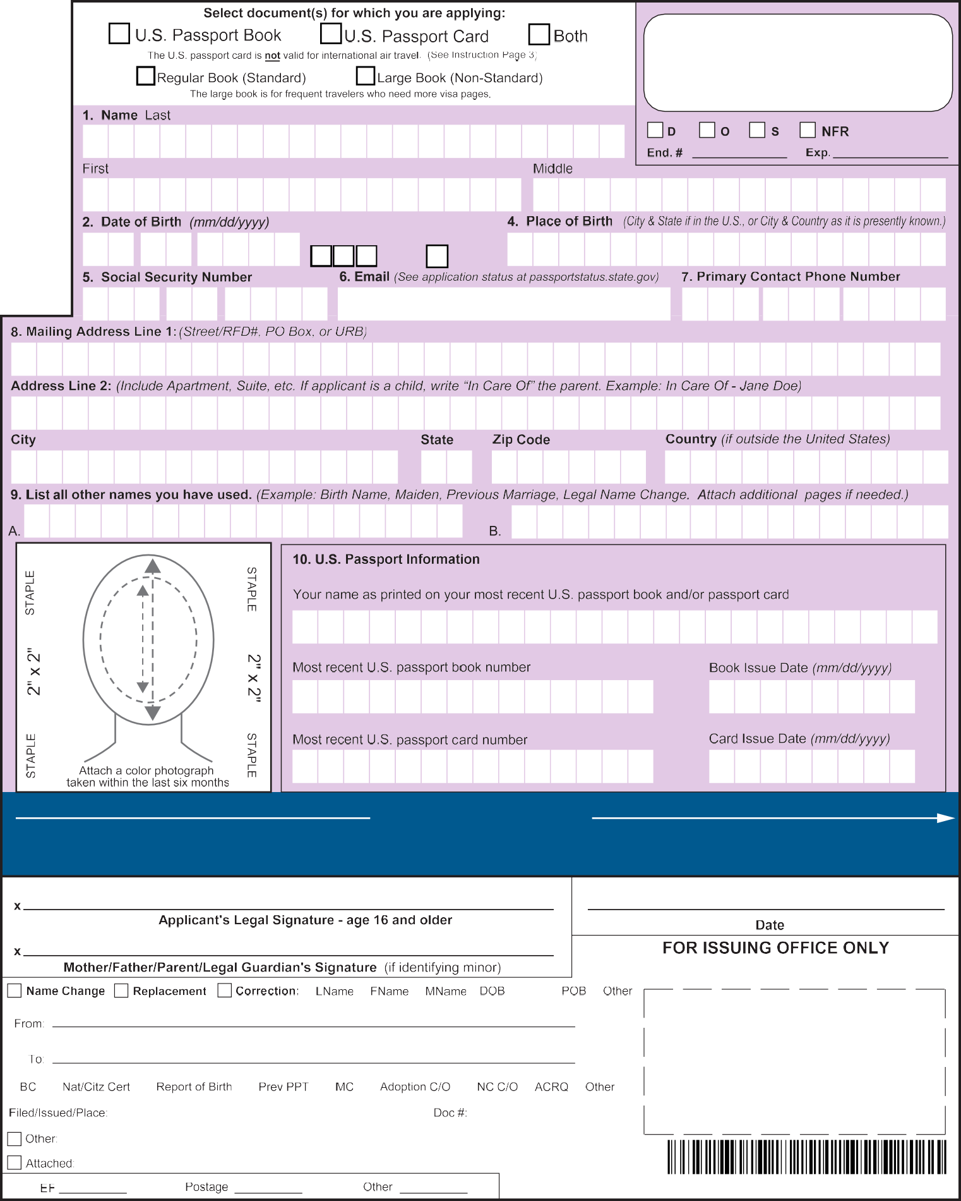

###### YOU MUST SIGN AND DATE THE APPLICATION IN THE DESIGNATED AREA BELOW THEN COMPLETE PAGE 2

FROM 1” TO

1 3/8”

I declare under penalty of perjury all of the following: 1) I am a citizen or non-citizen national of the United States and have not performed any of the acts listed under "Acts or Conditions" on page 4 of the instructions of this application (unless explanatory statement is attached); 2) the statements made on the application are true and correct; 3) I have not knowingly and willfully made false statements or included false documents in support of this application; 4) the photograph submitted with this application is a genuine, current photograph of me: and 5) I have read and understood the warning on page 4 of the instructions to the application form.

Gender

## DS 5504 C 03 2022 1

#### DS-5504 04-2022 Page 1 of 2

1. Has your name changed by marriage or court order less than one year after your U.S.

**passport book and/or card was issued?**

Yes No

1. If yes, and your submitted passport book and/or card is less than one year old, please complete this section with your new name.

**Name** Last

First Middle

Note: You must submit evidence documenting your name change (such as a certified marriage certificate or a certified court order) and your current U.S. passport book and/or card, along with this completed form to the address listed on Instruction Page 3.

If you cannot or did not meet the above criteria, please complete form DS-82, U.S. Passport Renewal Application for Eligible Individuals or form DS-11, Application for a U.S. Passport.

1. Was your identifying information printed incorrectly in your U.S. passport

**book and/or card?**

Yes No

If yes, **only check the box(es) next to the field(s) that need to be corrected** and complete the information as it should appear.

**Name** Last

First Middle

**Date of Birth** (mm/ddyyyy) **Gender Place of Birth** *(State or Country)*

M F X

Note: Please submit evidence documenting your correct identifying information (such as a certified marriage certificate or birth certificate, if applicable) and your current U.S. passport book and/or card, along with this completed form to the address listed on Instruction Page 3.

Visit travel.state.gov for information on gender markers.

1. **Was your most recent U.S. passport book limited for two years or less?**

Yes No

If yes, please submit evidence of your U.S. citizenship (such as U.S. birth certificate or naturalization certificate) and/or evidence of your identity (such as a driver's license or state-issued ID card).

Note: To complete a limited U.S. passport book replacement, **your submitted U.S. passport book must not be expired.** Passport books limited in validity because of multiple losses, damages, or mutilations cannot be extended.

Please be sure to enclose your U.S. passport book along with this application to the address listed on Instruction Page 3.

## DS 5504 C 03 2022 2

### DS-5504 04-2022



**Clear Form**

Page 2 of 2